**Launching Your Own Website: A Beginner's Guide with AWS**

Ever dreamt of having your own corner of the internet? This guide will walk you through setting up a personal website using Amazon Web Services (AWS). No coding experience required!  
  
**AWS Services Used:**

1. Route53
2. S3 Bucket

**Architecture used:**

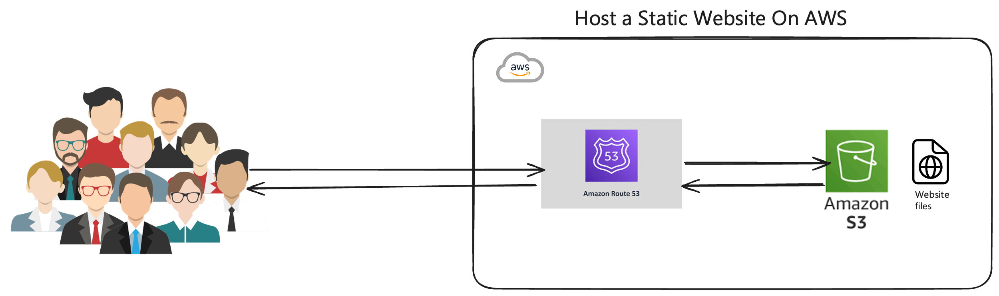

**Steps to follow:**

**Design Time!**

First things first, let's get creative. You can design your website from scratch or grab a free template from [free-css.com](https://free-css.com/).

**AWS Setup: Up and Running**

Now, we'll head over to the AWS Management Console. Here's what to do:

**Bucket Up with Amazon S3**

1. **Search for "S3"** and open the Amazon S3 console.
2. **Create a Bucket**: Click "Create bucket" and choose a unique name for your website's files.

**Enabling Website Hosting on S3**

1. **Static Website Hosting**: Under "Properties," look for "Static website hosting" and enable it. This lets AWS serve your website files.

**Upload Your Files to S3**

1. **Upload Files**: Drag and drop your website's files (HTML, CSS, etc.) into the bucket.

**Going Public (for Now) with S3**

1. **Set Permissions**: To allow everyone to see your website, set the bucket permissions to public access. (We'll tweak this later for security.)

**Your Custom Domain with Amazon Route 53: Owning Your Web Address**

Let's give your website a recognizable address!

**Head to Amazon Route 53**

1. **Search for "Route 53"** and open the console.

**Domain Registration with Route 53**

1. **Register Domain**: Click "Domain registration" and then "Register domain."
2. **Purchase Domain**: Follow the steps to purchase your custom domain name (e.g., yourname.com). This will be your website's unique web address.

**Creating a Record Set in Route 53**

1. **Route 53 Hosted Zones**: In "Route 53 hosted zones," create a new record set.
2. **Enter S3 Endpoint**: Here, you'll enter your S3 bucket's endpoint as the target. This connects your domain name to your website files.

**Congratulations!**

You've launched your website on AWS. Now you can access it using your custom domain name!